I will #SleepOut
in Philadelphia PA
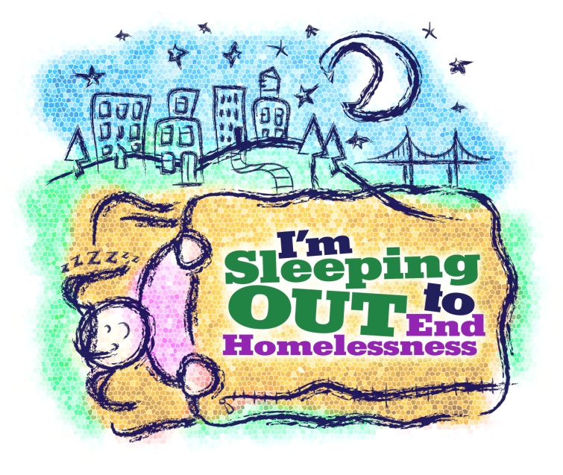to #EndFamilyHomelessness

#BridgeOfHope

