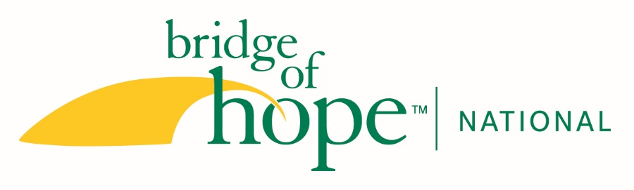
JOB DESCRIPTION

Title: Administrative Specialist

Reports to: Chief Financial Officer

Hours: Full-time, in office position based in Malvern office Monday-Friday

Qualifications:
- Attention to detail for data entry
- Ability to organize work and accomplish tasks proficiently
- Working knowledge of databases and ability to learn new software quickly
- Strong Microsoft Office skills
- Ability to communicate clearly with good interpersonal skills
- Three or more years of experience
- Able to facilitate a healthy, friendly atmosphere and sense of teamwork among all staff.
- An understanding of and commitment to the vision of Bridge of Hope National: To engage Christian faith communities in ending family homelessness through neighboring relationships that demonstrate Christ’s love.

Position Summary: To provide data entry and expertise for NXT database, including entering incoming donations in the donor database, preparing receipt letters, maintaining the donor database and all other administrative tasks as needed

Responsibilities:
- Fundraising database entry and maintenance (60% of time)
- Promptly acknowledge gifts given to Bridge of Hope National on a daily basis. This includes entering all gifts into database and printing or emailing receipt letters.
- Update database with changes and notes received from donors in daily gifts, this includes things on the check that might give hints about who the donor is and what their giving preferences/patterns are.
- Add new accounts into database and accurately update accounts with names, addresses, mail codes, relationships, solicitor, and other information with information provided by the Chester County staff, the Development Team, or other National staff members.
- Record non-cash contributions in database.
- Generate daily thank-you call listing for development staff.
- Run basic queries in database as needed or requested.
- Process/approve online gifts daily in database.

- General administrative support (25% of time)
- Serve as host to visitors coming into the office, extending hospitality and welcome to all who enter.
- Support the CEO in national board meeting venue planning, logistics and administrative needs of the national board, not including taking minutes.
- Support CEO in managing administrative details for two community boards.
- Provide administrative support for CFO and CEO as needed
- Responsible for all purchases, including office supplies and equipment, within allocated budgets.
- Answer phones and direct calls, as necessary and serve on team of Super Admins for the phone system.
- Scan documents into email or shared folders as needed.
- Assure daily morning postal pickup. Provide shipping/mailing services for office staff.
- Assist with mass mailings for various departments as needed.
- Receive and fulfill location resource orders and track inventory to assure appropriate timing for re-ordering and forward final amount owed to Office Administrator for invoicing.
- To work with Design/Printer vendor in ordering business cards, stationery and other office needs.

- Assist CFO with property management (5% of time)
- Monthly reconciliation of owner property statements from all property management providers.
- Provide support for all lease and master lease agreements.
- Coordinate/provide support of communication related to all properties.

- Events (5% of time)
- Conference Planning administrative support, before, during and after the conference.
- Provide administrative support before, during and after the Gala, including Gala On-site support, attend and participate as needed throughout the event and in advance of the event.
- Attendance at conference and Gala is required.

- Other (5% of time)
- Coordinate and carry out other work and projects as requested by Chief Financial Officer.
- Coordinate all in-office volunteer work for projects as needed.
- Attend staff meetings 3 times per month and all staff in-person gatherings
- Work with the year-at-a-glance document for this position, referring to it at least monthly and adding to it as necessary.

Physical Demands and Work Environment:
- Uses desktop computer with keyboard (>80% of the time)
- Occasionally lifts, carries, or otherwise moves and positions objects weighing up to 25 pounds

I have read and I understand the responsibilities and requirements of this position for which I have been employed by Bridge of Hope.

Employee Signature: __________________________
Date: ______________________________________

Updated: 4/25/2024, 2/26/2025, 5/5/2025, 7/17/2025

