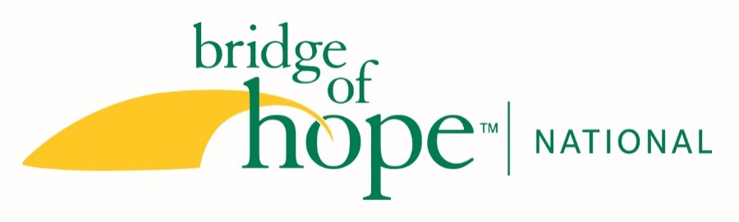
JOB DESCRIPTION

Title: Grant-writer and Communications Specialist

Report to: Chief Executive Officer

Hours: 30 hours/week

Hourly, non-exempt position, flexible hours, remote work option with occasional days in office. Core hours for this position are Mon-Thur, 10:00-3:00 p.m. Eastern.

Position Summary: This position focuses on grant-writing and relationship engagement with foundations (70%) will also providing written content for marketing/development and manages social media platforms (30%).

Qualifications and Experience:
- Five or more years of experience and success in grant-writing with private foundations
- Ease and enthusiasm in creating written content that builds engagement and relationships
- Strong strategic writing skills
- Working knowledge of nonprofit work, with 5+ years of marketing, development and/or communications experience.
- Ability to use stories to communicate mission
- Value system and personal style that is collaborative, ethical, Christian, persuasive, credible and fun.
- Passionate about Bridge of Hope National’s mission of engaging Christian faith communities in ending family homelessness through neighboring relationships that demonstrate Christ’s love.
- College degree or equivalent life experience.
- Proficient Computer skills; knowledgeable of donor software systems and Microsoft Office products such as Outlook, Word, Excel, PowerPoint
- Outstanding interpersonal, organizational and communication skills, high levels of self-motivation, optimism, and creativity
- Commitment to work collaboratively
- Ability to create communication plan at both the strategic and tactical levels
- Able to work independently and enjoys creating, implementing and managing new initiatives

Responsibilities:

Grant-writing
- Research and write grants for Bridge of Hope National (including program work in Lancaster and Chester County), as well as joint grants with or between other affiliates.
- Research future potential foundation partners nationally, and in Lancaster and Chester Counties.
- Meet annual goal set for foundation income.
- Build relationships with foundations and do follow-up reporting.
- Work with affiliates in the same state/region as the national office, where multiple affiliates are located in the same funding regions and where joint approaches by multiple affiliates for a larger grant would be most effective.
- Promote the sharing of grant proposals and grant-writing expertise and experience among affiliates and across the network.

Design and implement online year-end appeals
- Meet with development team to share/brainstorm theme for appeal themes and communications plan for implementation.
  - Work with writing and executing written and online appeals.
- Draft campaign plans for Spring Appeal, Summer Initiative, Fall Appeal, ExtraGive, Giving Tuesday and the Year-End campaign, including emails, social media and postcards.
- Analyzing giving trends from appeals to discern what is working

Serve on the Marketing team, including development and implementing of an annual communications plan. Oversees communications with constituents, editing, proofing other communications.
- Manage the content for all print and electronic collateral including, but not limited to, newsletters (3 per year), county inserts (annually), Impact Report (annually), brochures, and the website. Assist with the development of other marketing materials, focusing on development materials and public relations.

Oversee and approve content for all videos produced by Bridge of Hope for the general public and/or donors.
- Work with Project and Event Manager on production and outsourcing of videography and/or Location Resource Coordinator for videography if done in-house.
- Serve as on-site set-design/producer when videos are produced in Lancaster/Chester County regions.
- Assure all videos are consistent with our 4 values and maintain identity standards and commitment to quality products.

Social Media and Website Communications
- Lead generation of online content that engages audience segments and leads to measurable action.
- Work to maximum SEO and analytics, building on what is working based on our metrics, for best external communication.
- Create and implement social media and digital strategy for communications, fundraising and outreach.
- Coordinate (post, maintain) and expand Bridge of Hope National’s social media presence (Facebook, LinkedIn, Instagram, YouTube)
- Coordinate webpage content, ensuring that new and consistent information (article links, stories, and events) is posted regularly

Special Projects related to communications, development, marketing and location support
- Work as a team with other staff to ensure that Bridge of Hope National holds out the vision and big picture for the growing movement of Bridge of Hope in all marketing and communication pieces.

Other duties as assigned by the CEO and Chief Development Officer

