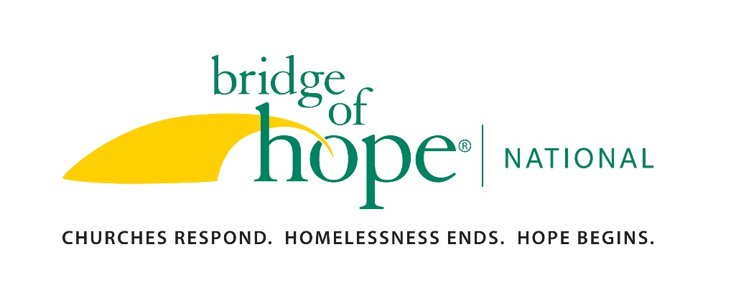
Please return this application and a resume (pdf format preferred) to: AndreaP@bridgeofhopeinc.org

EMPLOYMENT APPLICATION

PERSONAL INFORMATION

Full Name:

Full Address:

Phone Number: Email address:

Are you lawfully eligible for employment in this country? Yes_______ No_______

What position are you applying for?

List any experience, skills or qualifications that would equip you for this position:

PROFESSIONAL REFERENCES: Give the names of three persons not related to you, whom you have known at least one year and whom we can call for references.

Name | Phone  Number | Address | Business | Years  Acquainted

CHURCH FAITH/COMMUNITY INFORMATION
The mission of Bridge of Hope National is to engage Christian faith communities in ending family homelessness through neighboring relationships that demonstrate Christ’s love.

- Please sign the following statement if it describes your personal experience and commitment:
Bridge of Hope National is a Christian, faith-based organization which is funded by individuals and businesses who embrace the mission. Since Bridge of Hope is engaging Christian faith communities in ending family homelessness, I acknowledge that I have an active Christian faith commitment and am a part of a Christian community of faith. If employed by Bridge of Hope National, I would endeavor to demonstrate Christ's love in my work.
Signature_____________________________________________________

- Are you actively involved in a Christian faith community (ex: church, Bible Study, House-Church, etc.)? If so, please provide the name, address and pastor/leader’s name.

- Why do you believe that Christian faith communities can be a resource for ending family homelessness?

OTHER INFORMATION
- List any other information you want to share about community or church involvement, hobbies or special interests:

- State any additional information you feel may be helpful to us in considering your application.

- We require all employees to be vaccinated for COVID-19. Are you vaccinated? ___ Yes ___No
If no, do you have a valid medical or religious exemption? ___ Yes ___No

It is understood and agreed that any misrepresentations by me in this application and the attached resume is grounds for cancellation of this application and/or termination from employment (if employed). Furthermore, I understand that just as I am free to resign at any time, the employer reserves the right to terminate my employment at any time, with or without cause, and without prior notice. I understand that no representative of Bridge of Hope National has authority to make assurances to the contrary. I give Bridge of Hope National the right to investigate all references supplied and to secure additional information about me, if job related. I hereby release from liability Bridge of Hope National and its representatives for seeking this information and all other persons, corporations or organizations for furnishing this information.

Signature_______________________________________ Date_________________

