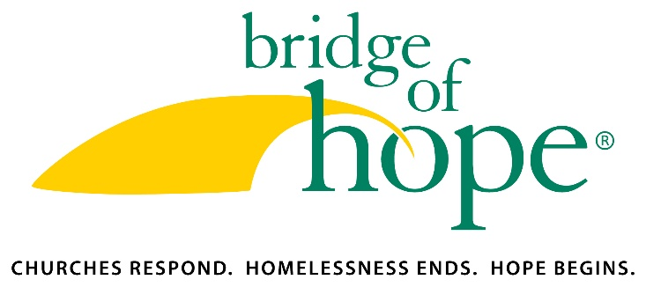

JOB DESCRIPTION

Title: Chief Advancement Officer

Report to: Chief Executive Officer

Hours per week: Full-time or part-time, based on the preference of the top candidate. (Note that this job description is outlined for a full-time candidate and would be revised in expectations for a part-time role.)

Position Base: This position allows for the possibility of working from a home office within easy access of Chester County/Lancaster County, PA. Travel to the national office in Malvern will be necessary at least several times a month.

Travel Requirements: Travel required for donor visits, many of which will be in the Chester/Lancaster County, PA region. Includes in-person attendance at board meetings twice a year and the annual Bridge of Hope conference.

Position Summary: The Chief Advancement Officer will provide strategic leadership to the Bridge of Hope marketing and development functions and a staff of four people. This person will also carry a small portfolio of major donor relationships.

Education and Experience:
- Bachelor’s degree required.
- Seven+ years of experience in fundraising.
- Five+ years in marketing/communications.

Qualifications/Skills:
- An understanding of and commitment to the mission of Bridge of Hope: To engage Christian faith communities in ending family homelessness through neighboring relationships that demonstrate Christ’s love.
- Lives out the Bridge of Hope values of following Jesus, engaging the church, choosing hope and practicing cultural humility.
- Demonstrated personal initiative
- Strong organizational skills
- Prior supervisory experience required.
- Experience producing articles, telling stories and editing the work of others required.
- Experienced project leadership in managing development projects
- Proven success in development for a large nonprofit. Experience running campaigns and successful strategies across donor channels.
- Excellent written and oral communication skills: skilled in creating powerful, compelling written and oral communications. Ability to convey complex ideas through brief, simple materials.
- Ability to collaborate, motivate, influence and encourage teams and individuals.
- Skilled relationship builder
- Committed to excellence in nonprofit, faith-based marketing and development
- High proficiency and comfort in computer technology, including Microsoft Office products, remote desktop and video-conferencing.

Critical Executive Leadership Competencies:
- Cultivates Relationships: Initiates and maintains strategic relationships with donors and stakeholders inside and outside the Bridge of Hope network.
- Leads with Cultural Humility: leads with a spirit of cultural humility by approaching others with openness, setting aside assumptions, stereotypes and even cultural competencies in order to know another through their own lens and across all areas of diversity.
- Displays Strategic Influence: Creates and executes influence strategies that persuade key internal and external stakeholders to take action that will support Bridge of Hope’s mission and strategic direction. Proactively communicates the Mission.
- Inspires and Engages People: Passionately and effectively presents a transformational vision; creates a clear and compelling view of the future by helping others understand how Bridge of Hope outcomes will change lives.
- Lives out Ministry as Fundraising: Embraces and lives out fundraising as a way of engaging others in the work of God’s kingdom on earth.
- Models Integrity and Ministry Values: Genuinely cares about families facing homelessness and Christian faith communities who seek genuine ministry together; communicates openly and honestly to foster trust relationships among colleagues and team members.

Position Priorities:
  - Development Team Leader. Responsible to lead the entire development operation, strategies and team.
    - Secures financial contributions that leverage other sources of funding.
    - Works with CEO to create and monitor income side of budget and various expense categories.
    - Creates, oversees and helps implement the annual development plan and strategy.
    - Builds a robust donor base.
    - Manages a development team that is growing in donor relationship building and visits.
    - Trains and mentors development staff toward their fundraising position goals.
  - Relationship Manager, with a portfolio. Leads by example with strong donor visits and relationships, with approximately 30-35 Leader of Hope Giving Society members in their portfolio.
  - Marketing Team Leader. Responsible to lead the big-picture marketing strategy of Bridge of Hope and oversee team members.
    - Creates, oversees and helps implement the annual marketing plan and strategy.
    - Oversees brand management, including overseeing and protecting brand and trademark.
    - Assures network-wide consistency within the Bridge of Hope Identity Standards.
    - Serves as first point of contact for crisis communication.
  - Member of Leadership Team. Works with CEO and other leadership team members on vision, strategic plan and organizational leadership.
  - Defines roles, responsibilities and measurable objectives for members of the Advancement and Communications teams. Engages in regular interaction with team and individual members to provide coaching, team building and ensure accountability.

